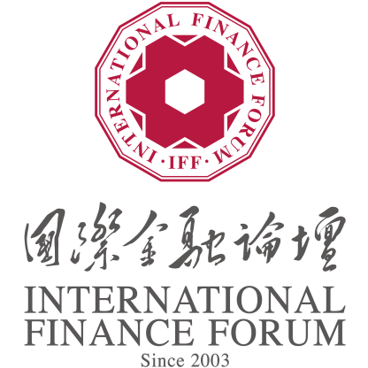

International Finance Forum (IFF)
2023 Global Green Finance Award - Spark Award

Application Form

Applicant:

Institution Information
Institution Name
Date of Establishment
Domicile
China’s Mainland Hong Kong SAR, Macao SAR or Taiwan, China Asia Pacific ex-China North America Latin America Europe Middle East and Africa

Applicant Contact Information
E-mail
Website
Contact information | Name
 | Position
 | Phone Number
 | Email
Referrer
Name
Title of Referrer
Name
Title of Referrer
1.Institution Introduction (No more than 300 words).
2. Institution Evaluation
2.1 Contributions to the global or national/regional promotion of green transition, addressing climate risk and SDGs through financial instruments
2.1.1 Institution’s global / regional contribution
(No more than 300 words)
Score Recommended by the Secretariat
2.1.2 Institution’s contribution to key sustainability issues
(No more than 300 words)
Score Recommended by the Secretariat
2.2 Fostering innovation in driving green transitions, addressing climate risks, and achieving SDGs through financial instruments
2.2.1 Innovation supporting mechanism of Institution
(No more than 300 words)
Score Recommended by the Secretariat
2.2.2 Innovative measures in institutional practice (No more than 500 words)
Score Recommended by the Secretariat
2.3 Sustainability of the institution's innovative practices, including but not limited to improving the level of public service, social well-being, environmental governance, and profitability
2.3.1 Strategy and vision (No more than 200 words)
Score Recommended by the Secretariat
2.3.2 Sustainability of institutional green finance practices (No more than 300 words)
Score Recommended by the Secretariat
2.3.3 Profitability of institutional green finance practices (No more than 300 words)
Score Recommended by the Secretariat
2.3.4 Positive social impact (No more than 300 words)
Score Recommended by the Secretariat
2.3.5 Positive environmental impact (No more than 300 words)
Score Recommended by the Secretariat
2.4 Promotability and replicability of institutional innovation practices
2.4.1 Promotability (No more than 300 words)
Score Recommended by the Secretariat
2.4.2 replicability (No more than 300 words)
Score Recommended by the Secretariat
3.Statement of Applicant Institution
I, on behalf of the organization where I am from, hereby make a solemn statement regarding the participation in the evaluation of the International Finance Forum (IFF) 2023 Global Green Finance Award.
We fully understand and agree with the requirements of the International Finance Forum (IFF) 2023 Global Green Finance Award - Spark Award. All documents submitted are true and correct.
We agree that the organizer has the right to keep the application materials and release in public, to promote international exchanges and cooperation on good experiences and practices of green finance, and contribute to sustainable development and realization of Sustainable Development Goals (SDGs).

Signature of Representative (with official stamp)

Date:
4. Recommendations of the Secretariat
5. Total Score of the Project Recommended by the Secretariat
Note: The application form should be concise in all columns and should not exceed the required number of words. Detailed explanatory materials, charts, pictures, images, etc. can be provided in the form of attachments, with the title of "Spark Award - Name of the Institution - Number of the Column", and sent to gggc@iff.org.cn together with the application form. The subject of the email must state "IFF 2023 Global Green Finance Award - Spark Award - Name of the Institution". Application deadline: July 30, 2023.

