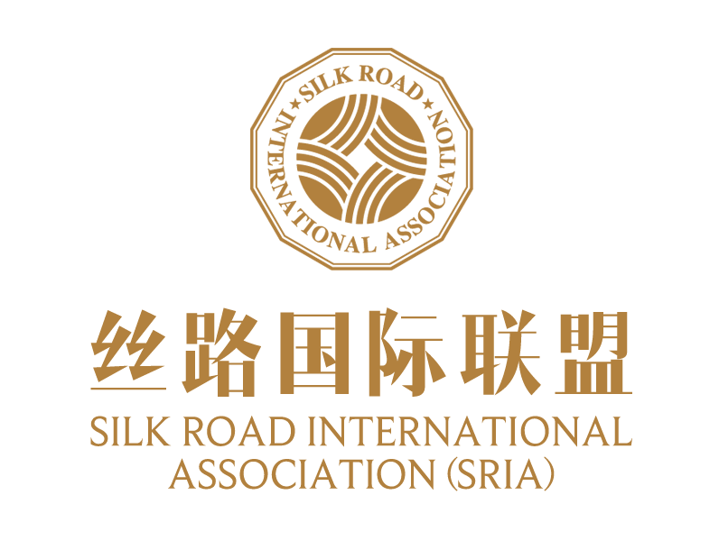

The 2nd ‘Belt and Road’ International Cooperation Award

Application Form

Applicant:

|  |  |  |  |
| --- | --- | --- | --- |
| **Institution Information** | | | |
| **Institution Name** | | | |
|  | | | |
| **Date of Establishment** | | | |
|  | | | |
| **Domicile** | | | |
| 🞎China’s Mainland 🞎Hong Kong SAR, Macao SAR or Taiwan, China 🞎Asia Pacific ex-China 🞎North America 🞎Latin America 🞎Europe 🞎Middle East and Africa | | | |
| **Applicant Contact Information** | | | |
| E-mail |  | | |
| Website |  | | |
| Contact Information | Name | |  |
| Position | |  |
| Phone Number | |  |
| E-mail | |  |
| **Referrer** | | | |
| Name | |  | |
| Position | |  | |
| Name | |  | |
| Position | |  | |
| **Institution Introduction (No more than 300 words)** | | | |
| |  |  |  |  | | --- | --- | --- | --- | | **Institution Evaluation (No more than 500 words for each indicator)** | | | | | **Primary Indicator** | **Secondary Indicator** | **Note** | **Content** | | 1. **Contribution to the ‘Belt and Road’ Initiative (25 points)** | 1.1 Alignment with the Goals of the ‘Belt and Road’ Initiative (10 points) | Active engage with the five major cooperation priorities of the ‘Belt and Road’ initiative: connectivity of policy, infrastructure, trade, finance and people; connectivity in the five priority areas of policy, infrastructure, trade, finance and people-to-people bonds. |  | | 1.2 Role in Regional Interconnectivity  (10 points) | Effectiveness in promoting interconnectivity in areas such as infrastructure, trade, investment, and cultural exchanges. | | 1.3 Embodiment of the principle of ‘extensive consultation, joint efforts and shared benefits’ (5 points) | Reflection of multi-party participation, equality in consultation, and mutual benefit and win-win cooperation in the project. | | 1. **Comprehensive Benefits**   **(25 points)** | 2.1 Economic Benefits  (5 points) | Contribution to regional economic growth, trade and investment, and employment. |  | | 2.2 Social Benefits  (5 points) | Effectiveness in improving people’s livelihood, promoting social inclusivity, and enhancing the well-being of the local community. |  | | 2.3 Environmental Benefits (5 points) | Performance in environmental protection, resource conservation, and green and low-carbon development. |  | | 2.4 Innovation and Sustainability (10 points) | Innovativeness in technology, model and management, as well as its long-term sustainability. |  | | 1. **International Cooperation Mechanisms and Capacity Building (20 points)** | 3.1 Diversity and Effectiveness of Cooperation Mechanisms  (10 points) | Innovativeness and effectivenessin partner selection, cooperative model design, and implementation mechanisms. |  | | 3.2 Support for Local Capacity Building  (5 points) | Enhancement of local capacity building through technology transfer, talent development, and other means. |  | | 3.3 Strength of the Cooperation Network and Synergy Effect  (5 points) | Degree of synergy among cooperation parties and the stability of the cooperation network. |  | | 1. **Inclusiveness and Multicultural Cooperation**   **(15 points)** | 4.1 Promotion of Inclusive Development  (5 points) | Effectiveness in promoting gender equality, social inclusivity, and the participation of vulnerable groups. |  | | 4.2 Integration and Innovation of Multiculturalism within the Project (10 points) | Capacity for integration in a multicultural context and its role in driving project innovation. |  | | 1. **ESG Risk Management and Transparency (15 points)** | 5.1 Assessment and Management of Project ESG-Related Risks (10 points) | Capacity for risk management in the areas of environment, society, and governance (ESG). |  | | 5.2  Disclosure and Transparency of Project ESG-Related Information (5 points) | Completeness, timeliness, and transparency of ESG information disclosure |  | | | | |

|  |
| --- |
|  |
| **Statement of Applicant Institution**  We fully understand and agree with the requirements of the ‘Belt and Road’ International Cooperation Award. We affirm that all submitted materials are true and correct. We affirm that all submitted materials and release in public, to promote international exchanges and cooperation under the Belt and Road Initiative, as best practices in poverty eradication, infrastructure development, transformation and upgrading of economic growth, combating environmental pollution, and addressing climate change to achieve sustainable development, and contribute to the realization of Sustainable Development Goals (SDGs) for the benefit and well-being of humankind.  Signature of Representative (with official stamp)  Date: |
| **Recommendations of the Secretariat** |
|  |
| **Recommended Total Score of the Project by the Secretariat** |
|  |
| Note:  ① The application form should be concise in all columns and should not exceed the required number of words. Detailed explanatory materials, charts, pictures, images, etc. can be provided in the form of attachments, with the title of “ ‘Belt and Road’ International Cooperation Award - Name of the Institution - Number of the Column”, and submitted together with the application form.  ② All the attachments and the application form should be sent to **[sria@](mailto:gggc@iff.org.cn)ifforum.org**. The subject of the email must state “The ‘Belt and Road’ International Cooperation Award-Name of the Institution”. Application deadline: August 15, 2025. |